

|  |  |
| --- | --- |
| e  e | Introduction to mbed OS  Mihail Stoyanov  Partner Enablement Team Lead, ARM mbed |

|  |  |
| --- | --- |
| e | ARM mbed Connect / China  December / 05 / 2016 |

© ARM 2016



|  |  |  |  |
| --- | --- | --- | --- |
| e | 2 | © ARM 2016 | mbed OS |
| Introduction |

|  |  |
| --- | --- |
| e  e  e | OS platforms for IoT and embedded § IoT is a disruptive jump in complexity for embedded software § Requirements for Connectivity à Security à Management |

§ Adoption of OS platforms is necessary for industry success

|  |  |
| --- | --- |
| § The cost and risk of projects building from scratch is too high§ A platform OS lowers the barrier to entry for new entrants  § IoT products require device management services |  |

§ Will become essential components within a platform OS

|  |  |  |
| --- | --- | --- |
| 3 | © ARM 2016 |  |

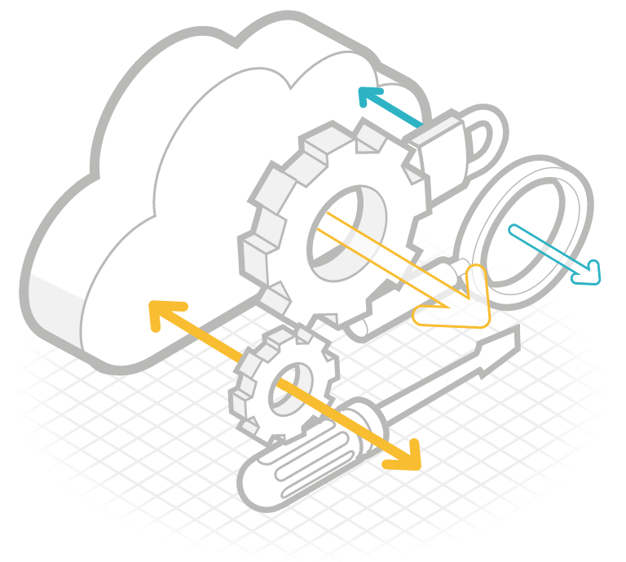

|  |  |
| --- | --- |
| e  e  e | Platform OS requirements § Accelerate the development of IoT devices  § Pre-integrate all the necessary connectivity and software components |

§ Provide across many hardware solutions

§ Accelerate the deployment of IoT devices

§ Solve the device management problems

§ Utilize ecosystem scale

§ In collaboration to provide maximum gearing and pace

|  |  |  |
| --- | --- | --- |
| 4 | © ARM 2016 |  |



|  |  |  |  |
| --- | --- | --- | --- |
| e | 5 | © ARM 2016 | mbed OS core |



e mbed OS core

e § Enables application and component libraries to work unchanged across MCUs

e § Provides portability for developers

§ Consistent boot and C/C++ runtime across MCUs Boot

§ Including support across different toolchains, std library integrations

|  |  |  |  |
| --- | --- | --- | --- |
| § RTOS kernel | Networking | mbed OS | CMSIS |
| Peripheral | **core** | C/C++ |
| § Built on the established, widely used, open source CMSIS-RTOS RTX |
| § Very small kernel optimised for constrained memory devices |
| drivers and HAL | RTOS and |
| runtime |
| § Peripheral driver APIs |
| events |

§ Common Driver APIs for all common peripherals, supported across all MCUs

|  |  |  |
| --- | --- | --- |
| 6 | © ARM 2016 |  |

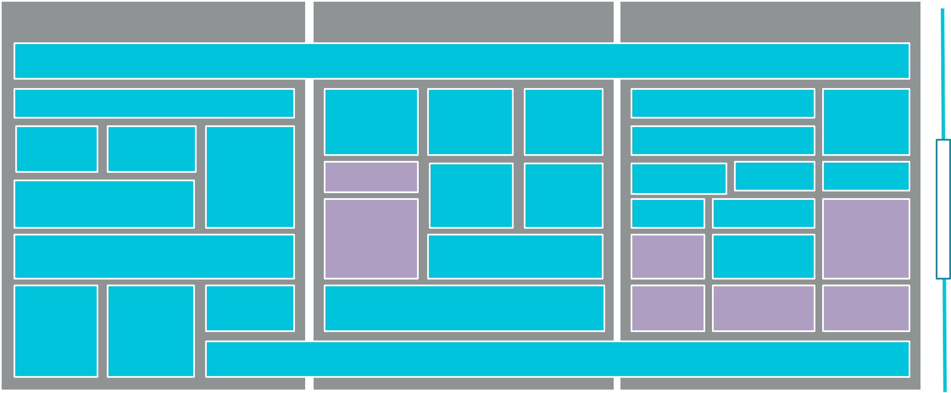

|  |  |  |  |  |
| --- | --- | --- | --- | --- |
| e | mbed OS stack | | |  |
|  | |  | | --- | | mbed OS component libraries (400+) | | |  | | --- | | mbed Cloud Client | | | Application Code |
| e |  | | mbed OS API | mbed OS connectivity |
| e | mbed OS core | mbed OS runtime | |

mbed TLS

|  |  |  |  |  |  |  |  |  |  |  |  |  |  |  |  |  |  |  |
| --- | --- | --- | --- | --- | --- | --- | --- | --- | --- | --- | --- | --- | --- | --- | --- | --- | --- | --- |
|  | FAT | Stream / file interface | | | Drivers | | | mbed | | mbed | | Sockets | | | Profiles | Is | |  | | --- | | mbed OS partners | |
| CFStore | | | Events | | RTOS | | IP Stack | | |
|  | and community |
|  | | | | CHAL | | Event | | CMSIS | | | | Ethernet | Thread |
|  | NVStore | | | | BLE | Security APIs | |  | | --- | | mbed Client | |
| Block storage | | | | MCU | | Loop | | RTOS | | | WiFi | | 6LoWPAN | BLE |
| components |
| C++ runtime / bootloader | | | | SDK | | CMSIS RTX | | | | WiFi | | | mbed |  |
|  | stack |  |  |
|  | stack | | | nanostack | BLE |  | |  | | --- | | Partner | |
| GCC | | ARM | GCC | CMSIS-Core | | | | | | Eth | | | 802.15.4 | components/ports |
| MAC | | | MAC | HCI |
|  |  |  |  |
|  |  |  | |  | | --- | | mbed OS | |
| mbed uVisor | | | | | | | | | | | | | |
| components |
|  |  | | | | | Hardware Interfaces | | | | | | | | |  |  |  |
|  | |  | | --- | | Root of trust | | | |  | | --- | | TRNG | | |  | | --- | | HW crypto | | |  | | --- | | Peripherals | | | | | | | |  | | --- | | Sensors | | | | | Radio |  |  |
|  | |  | | --- | | TrustZone for ARMv8M | | | | | |  | | --- | | ARM Cortex-M CPU | | | | | | | | | | |  |  |  |
| 7 | © ARM 2016 | | | | | | | | | | | | | |  |  |  |



|  |  |  |  |
| --- | --- | --- | --- |
| e | 8 | © ARM 2016 | mbed OS connectivity |

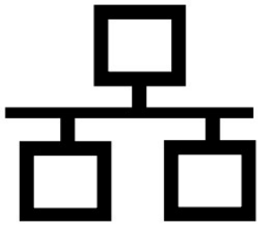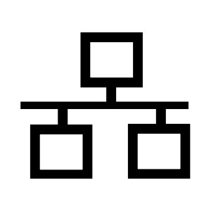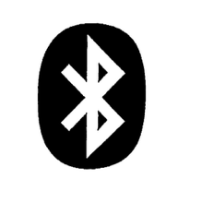

|  |  |
| --- | --- |
| e | mbed OS connectivity |

mbed OS connectivity

|  |  |  |
| --- | --- | --- |
| e | § Broad IoT connectivity |  |
| e | § Unified support of customer product |

portfolio

|  |  |  |  |
| --- | --- | --- | --- |
| § mbed partner and community | Bluetooth (BLE) | WiFi | 6LoWPAN |
| Sub-GHz Mesh |
| contributions |

§ Development hardware  
§ Software libraries

|  |  |  |  |
| --- | --- | --- | --- |
| § Tutorials and examples | NFC | Thread | LoRa LPWAN |

§ Commercial products and support

§ Future standards:  
 § Next-gen Industrial 802.15.4 Mesh

|  |  |  |  |  |  |
| --- | --- | --- | --- | --- | --- |
| 9 | § NB-IoT | RFID | Ethernet | Cellular |  |
| © ARM 2016 |

|  |  |  |  |
| --- | --- | --- | --- |
| e | 10 | Bluetooth Low Energy  § BLE has huge potential beyond its current application § Used in e.g. Google Eddystone beacons  areas§ Trusted robust radio, low cost chips, built into every mobile  § mbed OS BLE APIs already widely and successfully used § Portable across different vendors | |
| e |
| e |
| and laptop § Roadmap to longer range and IP |  |
| § Currently expanding support for BLE across more platforms |  |
| § Already supporting Cordio Radio IP, Nordic SoC, Maxim, ST | |
| © ARM 2016 |  |

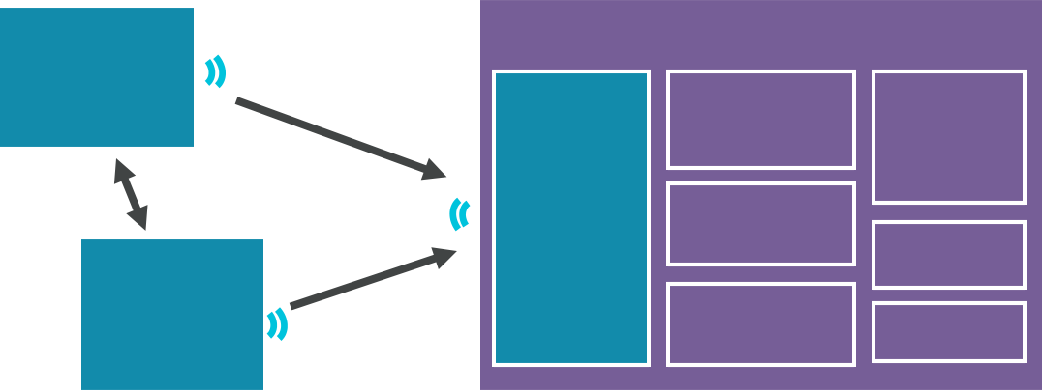

|  |  |  |
| --- | --- | --- |
| e  e  e | mbed OS 6LoWPAN 802.15.4 and Thread | |
| § Continue to be a leader in Thread implementation and standardisation § Also supporting generic 6LoWPAN 2.4GHz and Sub-GHz |  |
| § mbed OS implements MAC abstractions for simple transceiver support  § Enables any 802.15.4 SoC or transceiver access to   Thread/6LoWPAN |  |

§ Multiple transceivers now working, can be used with any   
 suitable mbed Enabled MCU

|  |  |  |  |  |  |  |  |
| --- | --- | --- | --- | --- | --- | --- | --- |
| 11 | § Border router and access point references available | Node | IEEE 802.15.4 | | Border | Access Point | Backhaul |
| Configuration, |
| network |
| § Focus on commercial, industrial and smart city | IEEE 802.15.4 | | | UI, IT Admin |
| (e.g. cellular, |
| VPN, tunnelling, | ethernet) |
| router | I/O, Extras |
| translation |
| © ARM 2016 | Router node | | IEEE 802.15.4 | Firewall | Logging |
|  |

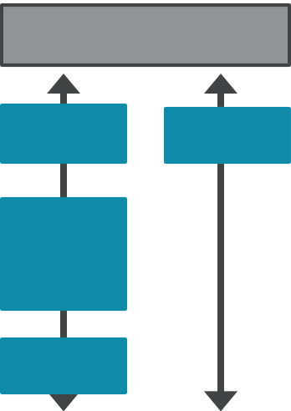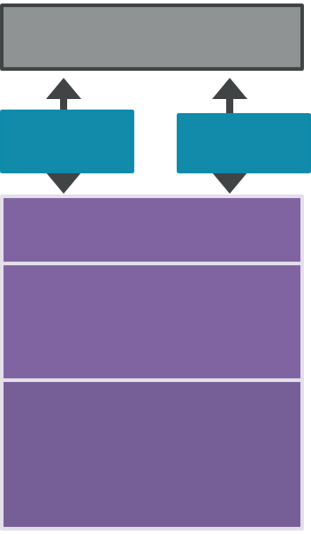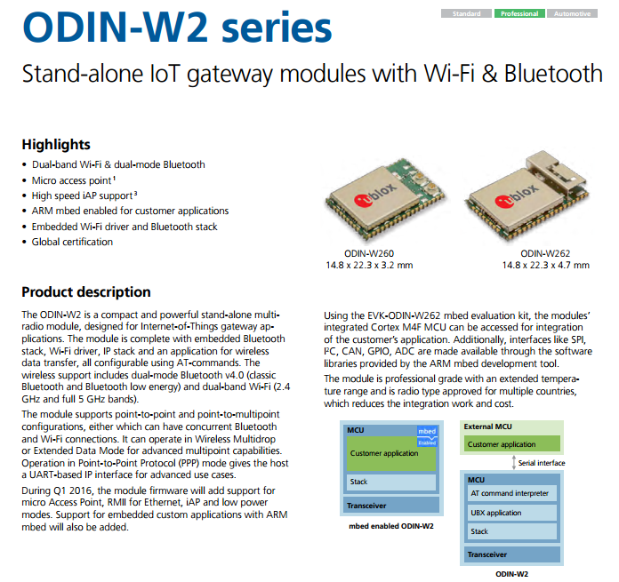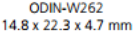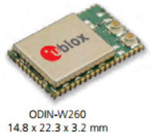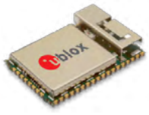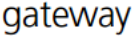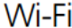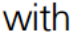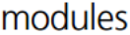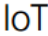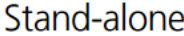

|  |  |  |  |  |  |  |
| --- | --- | --- | --- | --- | --- | --- |
| e | Enabling single module WiFi solutions | | App | Wi-Fi | App | |
| e | § mbed OS unlocks WiFi modules as a platform | |
| e | Socket | Wi-Fi  Config |
| § Application and OS runs on the integrated wireless modules | Socket |
| Config |
| data | | control | Socket adaptation | |
| § Enables BOM reduction and reduced design complexity | lwIP  2.0 |

internal IP stack

|  |  |  |
| --- | --- | --- |
| § Supports integration of different WiFi | lwIP | Wi-Fi HW adaptation |
| ethif |
| (driver) |
|  | Wi-Fi HW adaptation |  |
| architectures |
| (driver) |

§ WiFi MAC (mbed OS IP stack)

§ WiFi Network Processor (internal IP stack)

§ u-blox ODIN-W2 module support in   
 mbed OS 5.2

§ Look out for other partners landing their support

|  |  |  |
| --- | --- | --- |
| 12 | © ARM 2016 |  |

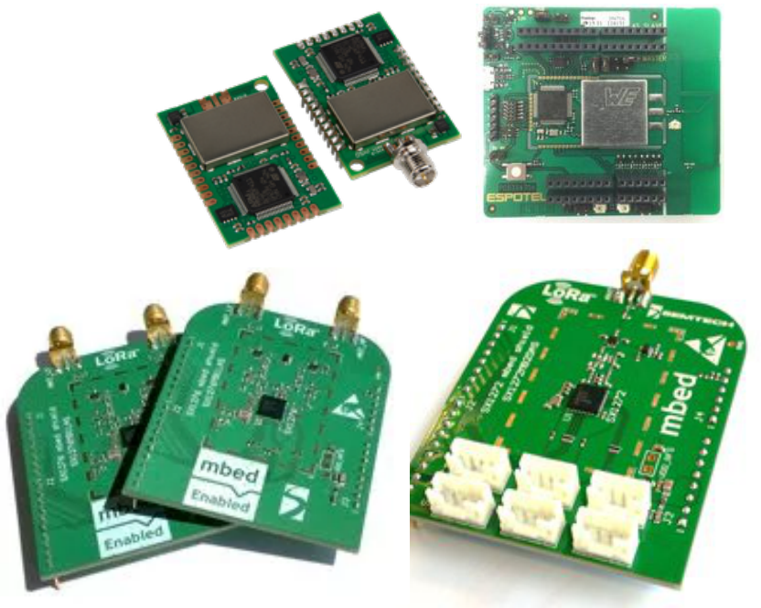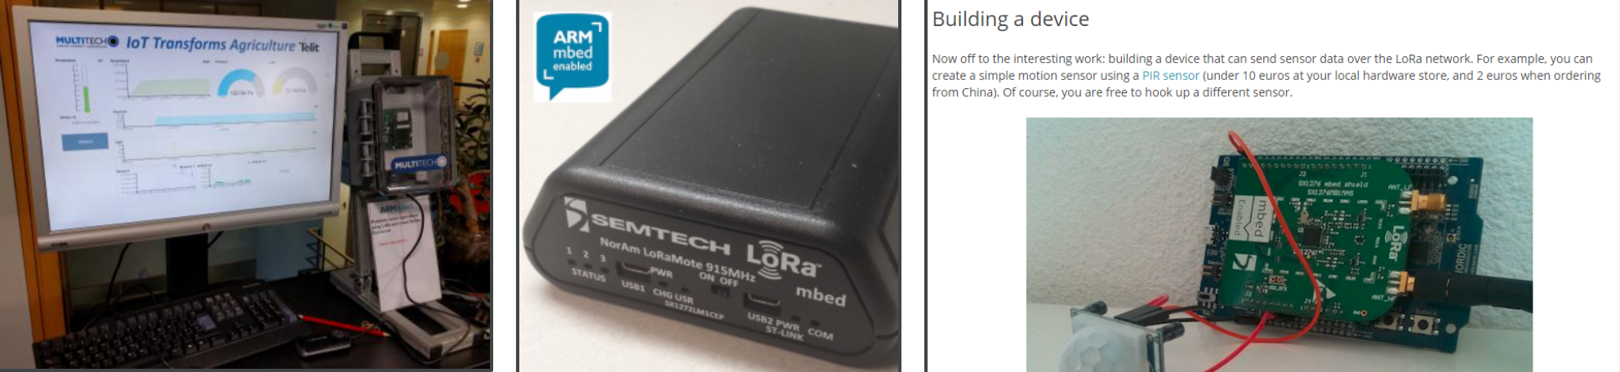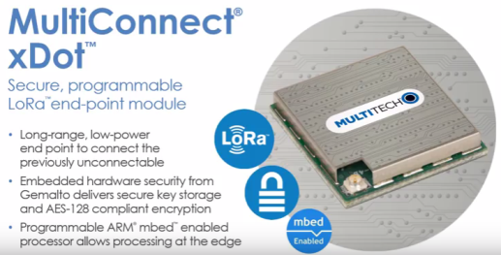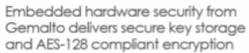

|  |  |  |
| --- | --- | --- |
| e | Native support for LoRaWAN |  |
| e | § mbed OS is already used for LoRa development |
| e | § We invested early in LoRa, and are planning to increase investment |

§ 7 LoRa hardware devices already in platform/component database

§ mbed LoRa examples imported 1000's times

§ Extending to provide integrated LoRaWAN support



|  |  |  |
| --- | --- | --- |
| 13 | © ARM 2016 |  |

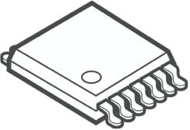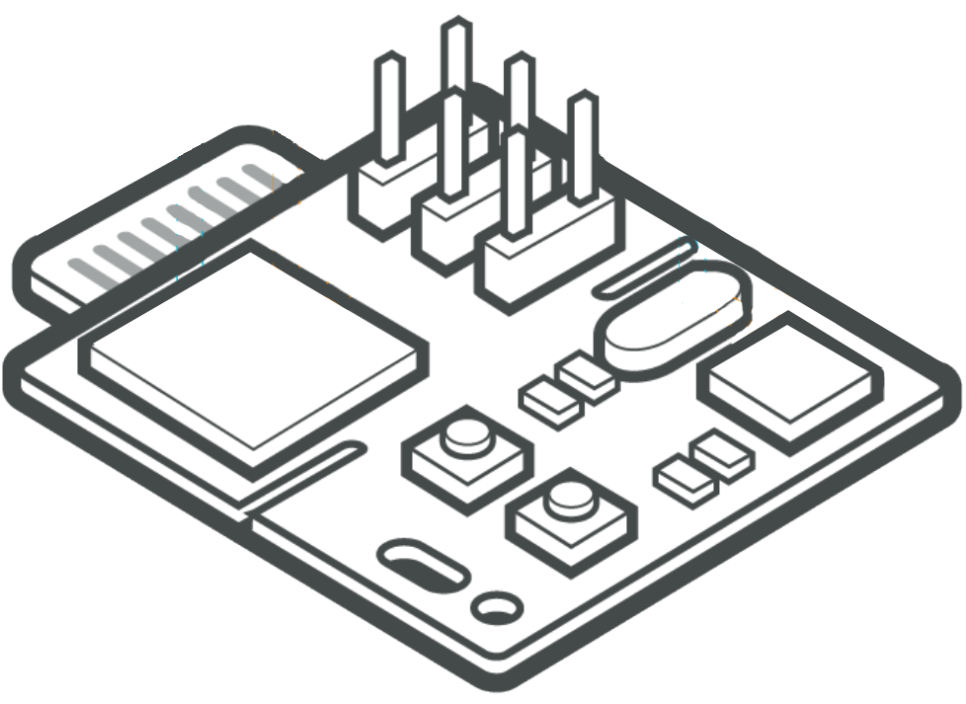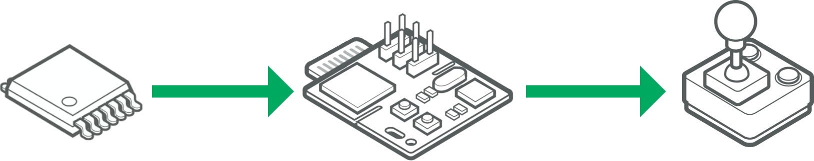

e mbed OS modules

e § Smart Modules will become a key building block for IoT products

e § Wraps up complexity to simplify product design – radio, application, services

§ Common design-in for IoT applications with initial runs of 10-100k units

|  |  |  |
| --- | --- | --- |
| Silicon | Module | OEM |

manufacturer manufacturer

§ Partnering with manufacturers on mbed Enabled wireless modules

§ WiFi, BLE, 802.15.4, LoRa

|  |  |  |
| --- | --- | --- |
| 14 | © ARM 2016 |  |



|  |  |  |  |
| --- | --- | --- | --- |
| e | 15 | © ARM 2016 | mbed OS security |



|  |  |  |
| --- | --- | --- |
| e | mbed OS security | mbed OS security |
| e | § Covers three main types of threat |

e

|  |  |
| --- | --- |
| § Security of system, including ability to provision, manage and update devices (e.g. security fix)  § Security of communications between device and cloud services  § Security and integrity of device itself from | mbed client  Lifecycle Security  mbedTLS  Communication Security  mbed uVisor  Device Security |

untrusted or malicious code

|  |  |  |
| --- | --- | --- |
| 16 | © ARM 2016 |  |

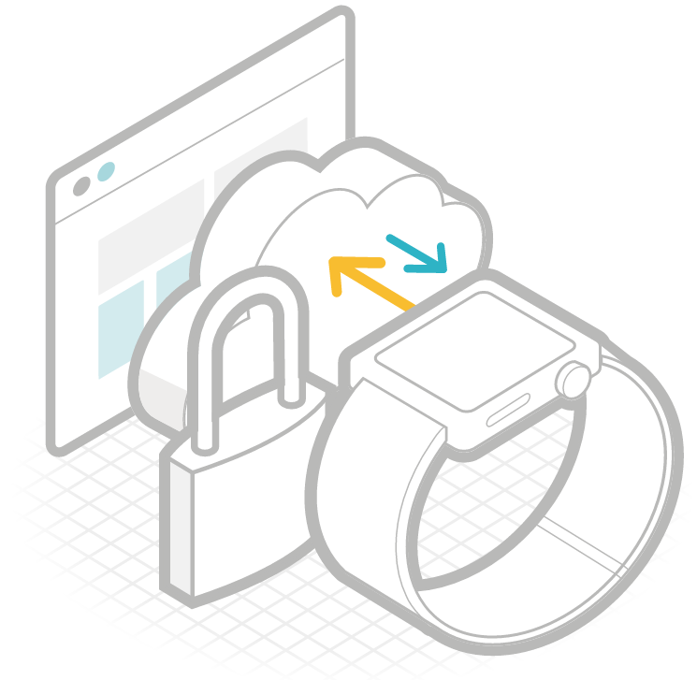

|  |  |
| --- | --- |
| e  e | mbed TLS § mbed TLS enables mbed OS cryptographic and SSL/TLS capabilities |

e

|  |  |  |  |
| --- | --- | --- | --- |
| 17 | Features: | § Symmetric encryption (AES, etc) |  |
| § SSL / TLS (SSL 3.0 up to TLS 1.2) | § Hash algorithms (SHA-2, etc) |
| § Extensive TLS Extension support | § Public Key algorithms (RSA, Elliptic |
| § X.509 certificate handling | Curves, etc) |
| § Abstraction layers | § Random number generation |
| (CTR_DRBG, etc) |
| § DTLS |
| © ARM 2016 |



|  |  |  |  |
| --- | --- | --- | --- |
| e | 18 | © ARM 2016 | mbed OS tools |

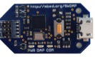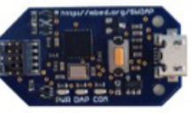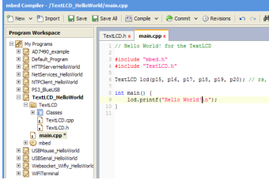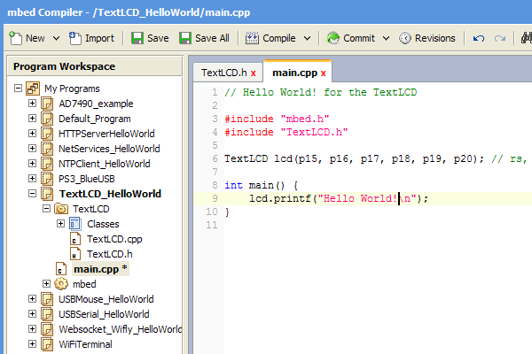

|  |  |  |
| --- | --- | --- |
| e | mbed OS tools | mbed OS DVCS support |



|  |  |
| --- | --- |
| e  e | § Free core tools provide build, debug, test and collaboration workflows |

§ Third party partner industry tools support   
 **mbed.org/code**

|  |  |  |  |  |  |  |  |
| --- | --- | --- | --- | --- | --- | --- | --- |
| 19 | © ARM 2016 | mbed OS core tools | mbed Greentea | mbed OS IDEs and toolchains | | |  |
| mbed CLI |
| Porting Testsuite and CI |
| Command Line |
| Interface | mbed pyOCD |  |  |  |
| mbed Compiler | CMSIS-DAP Debug Library | ARM Compiler 5 | | |
| mbed DAPLink |
| Free Online IDE |
| CMSIS-DAP Debug Firmware |

|  |  |  |
| --- | --- | --- |
| e | mbed CLI |  |
| e | § Single tool for fetching, configuring, building |
| e | and updating all source code that an mbed |
| OS program depends on |
| § Offline development - simple to install for |
| Windows, Mac OS X, Linux |
| § Backwards compatible with existing mbed OS 2 |
| programs and libraries |
| § Supports mixing multiple version control |
| backends: mercurial (hg) and git |
| § Supports building for multiple toolchains: |

ARMCC, GCC, IAR and exporting to IDEs

|  |  |  |
| --- | --- | --- |
| 20 | © ARM 2016 |  |

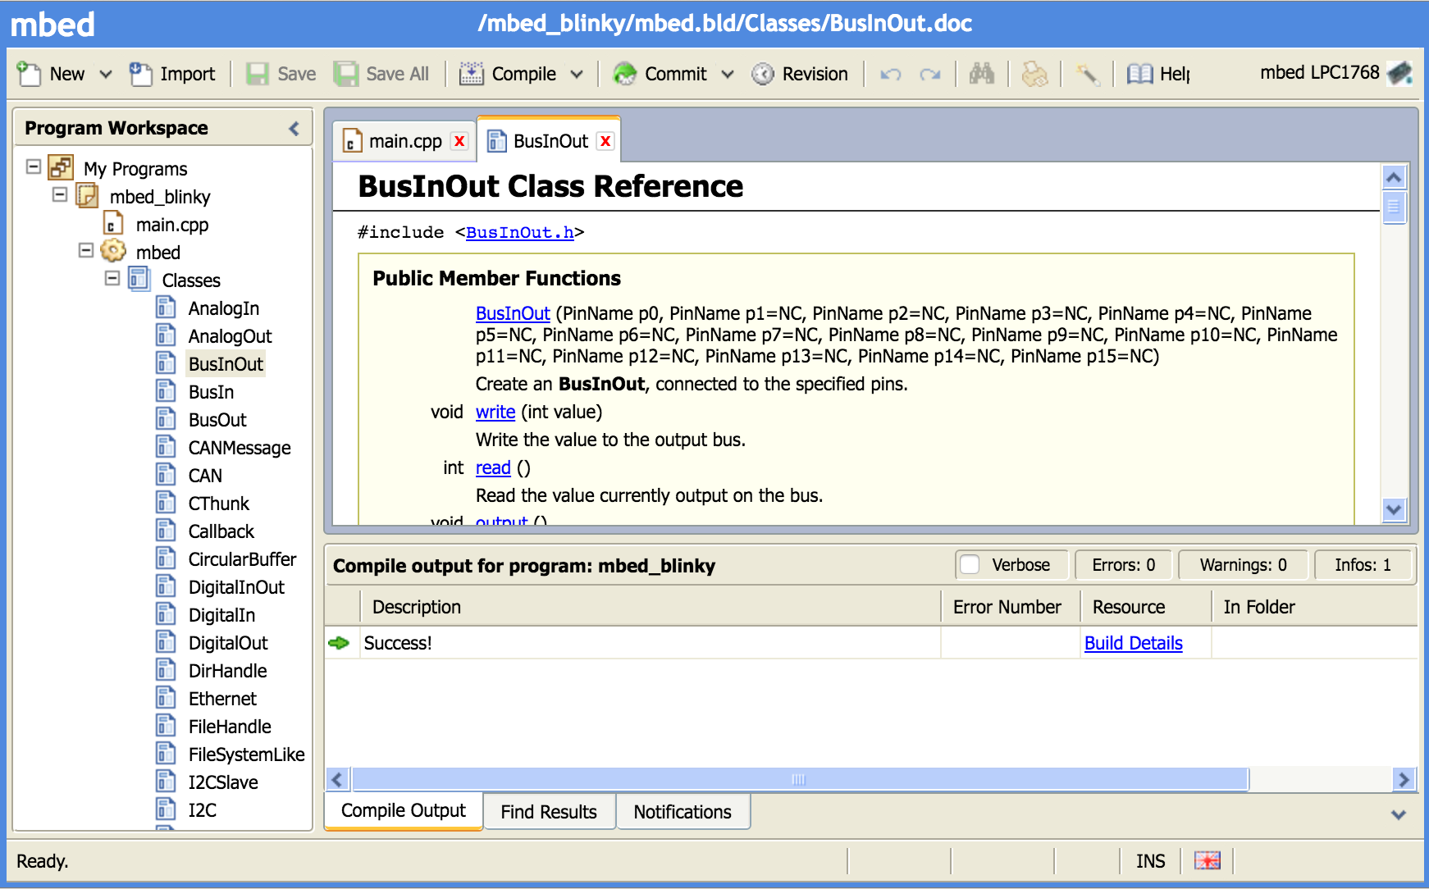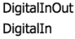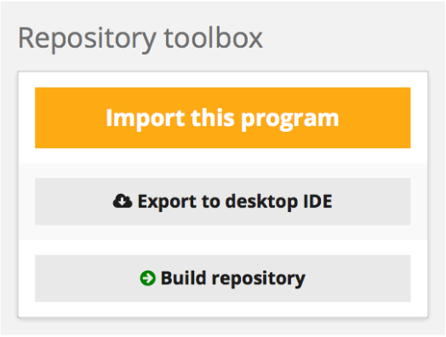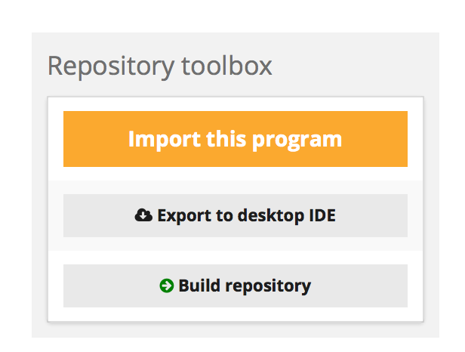

|  |  |
| --- | --- |
| e  e  e | mbed Online Compiler and third party IDEs§ mbed Online Compiler  § Instant access to working build environment |

§ Supports compilation, version control, publishing   
 projects, library documentation  
§ Compilation using ARM Compiler 5  
§ Free to use

|  |  |  |
| --- | --- | --- |
| § Third party IDEs  Develop and debug with your favourite IDE | |  | | --- | | > mbed export -i uvision -m K64F | |
| § § Export from mbed CLI or website to 3rdparty IDEs§ Keil uVision, IAR Workbench, GCC/Makefile, etc | ARM Compiler 5 |



|  |  |  |
| --- | --- | --- |
| 21 | © ARM 2016 |  |



|  |  |  |  |
| --- | --- | --- | --- |
| e | 22 | © ARM 2016 | mbed OS ecosytem |

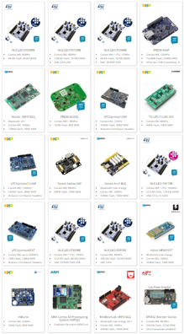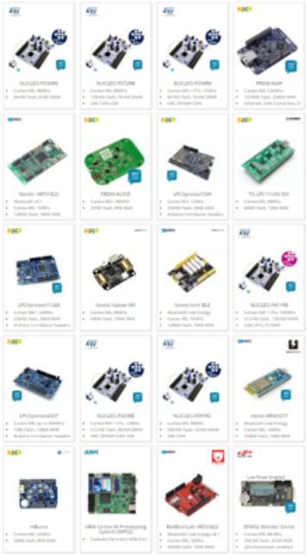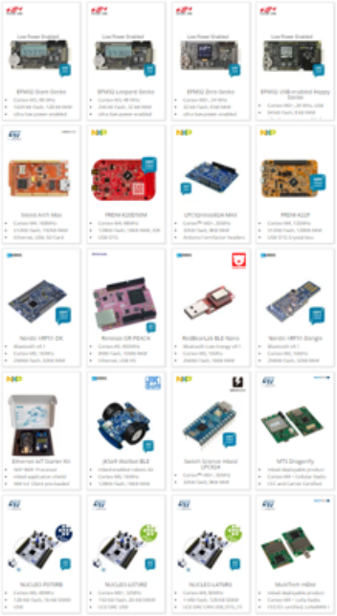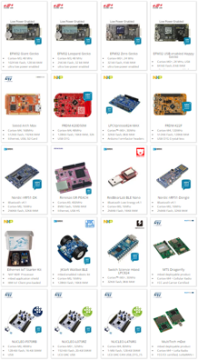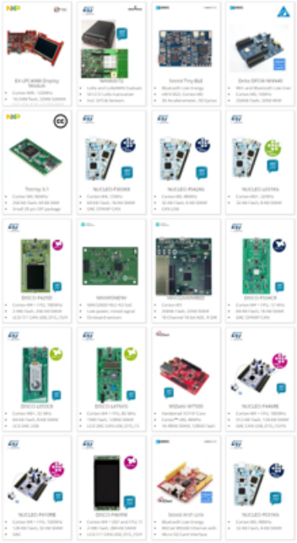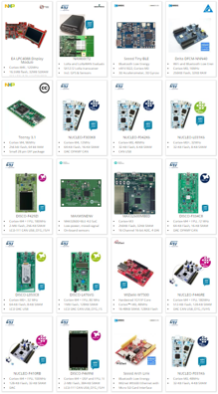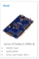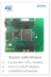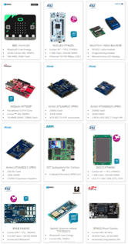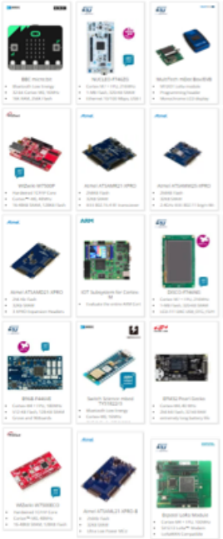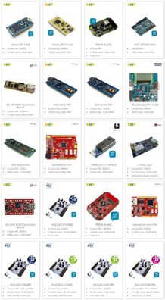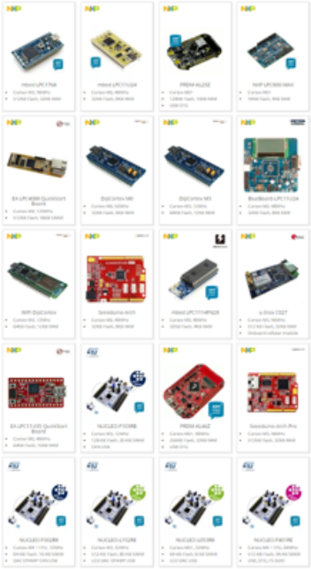

|  |  |  |
| --- | --- | --- |
| e | mbed OS partner ecosystem |  |
| e | § mbed OS runs on platforms from a wide range of MCU partners |
| § Cortex-M0 to Cortex-M7 |
| e | § Simple MCUs to full-featured IoT SoCs including radios |

§ Incremental effort for each partner, network effects for all

mbed OS Platforms

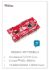

|  |  |  |
| --- | --- | --- |
| 23 | © ARM 2016 |  |

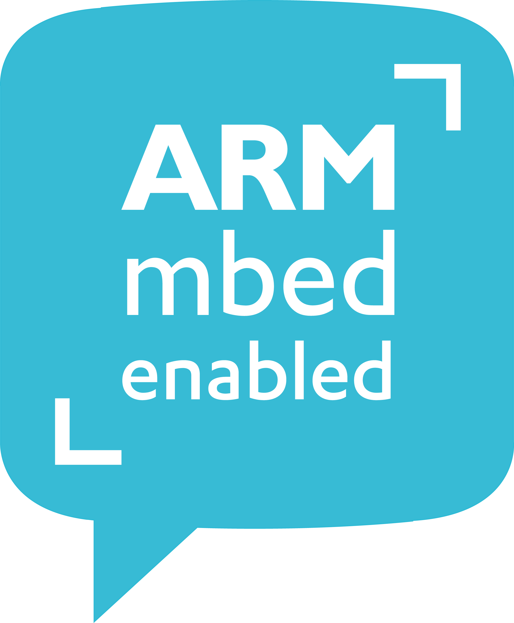

|  |  |  |
| --- | --- | --- |
| e | mbed Enabled |  |
| e | § mbed developers are looking for trusted |
| e | building blocks they know work with |
| mbed OS |
| § mbed Enabled offers partners a unique |
| opportunity to demonstrate IoT |
| compatibility, gaining customer mindshare |
| and reach new customers |

mbed Enabled is a mark of confidence for developers

|  |  |  |
| --- | --- | --- |
| 24 | © ARM 2016 |  |

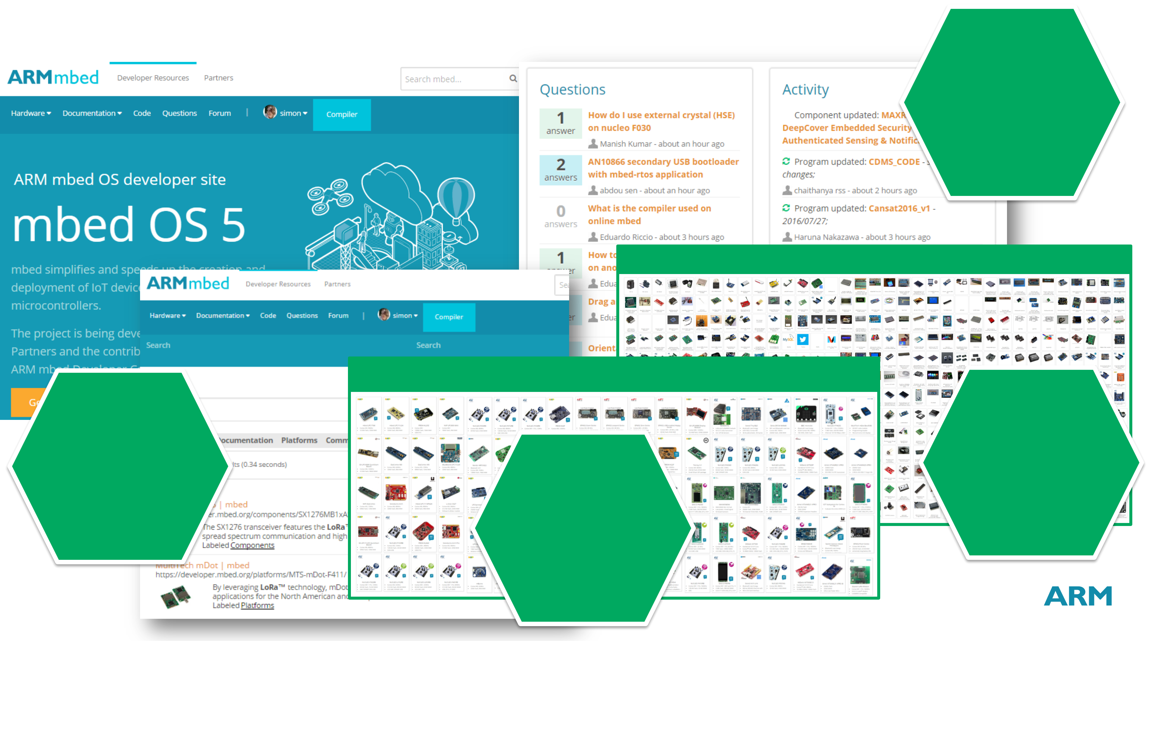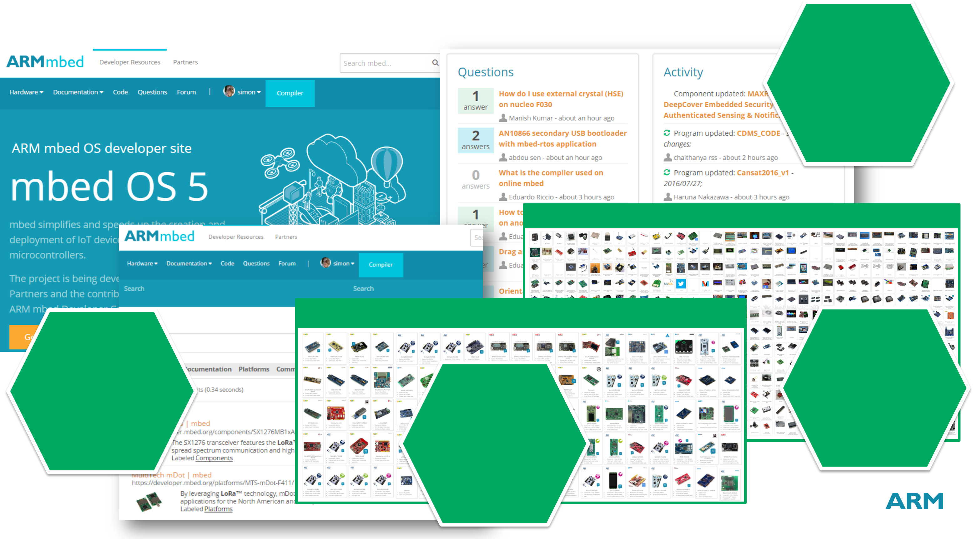

|  |  |  |
| --- | --- | --- |
| e | mbed OS developer community | 2M+ |
| e | Unique |
| visitors |
| e |

Components Database

mbed OS Platforms

|  |  |  |
| --- | --- | --- |
| 200K+ | 100+ | 400+ |
| Component |
| Registered |
| developers | libraries |

mbed OS

Platforms

25 © ARM 2016



e mbed OS 5

A **platform operating system**

|  |  |  |  |  |  |
| --- | --- | --- | --- | --- | --- |
| e | for the internet of things | Development | Cortex-M | Portable | **Developer** |
| **RTOS** |
| e |
| Kernel |
| **Partner** | **Tools** | **mbed OS** | **Drivers** |
| Ecosystem | Management | Integrated | Community |
| https://partners.mbed.com | **Services** | **Security** | https://developer.mbed.com |

IoT

**Connectivity**

|  |  |  |
| --- | --- | --- |
| 26 | © ARM 2016 |  |



Thank you

The trademarks featured in this presentation are registered and/or unregistered trademarks of ARM Limited (or its

subsidiaries) in the EU and/or elsewhere. All rights reserved. All other marks featured may be trademarks of their

respective owners.

Copyright © 2015 ARM Limited



|  |  |  |
| --- | --- | --- |
| e | mbed OS APIs –Threads and Timing | #include "mbed.h" |

|  |  |  |  |  |
| --- | --- | --- | --- | --- |
| e | § | Task | | DigitalOut led1(LED1); |
| void led2_thread() { |
| § | Thread: defining, creating, and controlling thread functions in the system |
| while (1) { |
| e | § | § | Mutex: synchronize the execution of threads | led2 = !led2; |
| § | Semaphore: manages thread access to a pool of shared resources of a certain type | wait(0.5); |
| } |
| § | Signals: wait for signals and be notified of events |
| } |
| § | Queue: queue pointers to data from producer threads to consumer threads |
| int main() { |
| § | MemoryPool: define and manage fixed-size memory pools |
| § | Mail: a queue providing a memory pool for allocating messages | Thread thread(led2_thread); |
| while (1) {} |
| Timing | |
| } |
| § | Ticker: set up a recurring interrupt |
|  |  | #include "mbed.h" |
| § | TimeOut: set up an interrupt to call a function after a specified delay |
| § | Timer: create, start, stop and read a timer for measuring small times | Ticker tick; |
| § | wait: busy wait of various resolutions |
| DigitalOut led1(LED1); |
| § | sleep: put the MCU to sleep |
| § | time: date and time functions | void flip() { led2 = !led2; } |

int main() {   
 tick.attach(&flip, 2.0);   
 while(1) {}   
}

|  |  |  |
| --- | --- | --- |
| 28 | © ARM 2016 | https://docs.mbed.com/docs/mbed-os-api-reference |

|  |  |
| --- | --- |
| e | mbed OS APIs – Basic I/O |

|  |  |  |  |  |  |  |  |
| --- | --- | --- | --- | --- | --- | --- | --- |
| e |  | § | Analog I/O | | | |  | | --- | | #include "mbed.h" | |
| BusOut myleds(LED1, LED2, LED3, LED4); |
| § | | AnalogIn: read the voltage of an analog input pin. | |
| e | § | | AnalogOut: set the voltage of an an along output pin. | | int main() { |
| § | Digital I/O | | | while(1) { |
| § | | DigitalIn: read a single digital input pin. | | for(int i=0; i<16; i++) { |
| myleds = i; |
| § | | DigitalOut: write to a single digital output pin. | |
| wait(0.25); |
| § | | DigitalInOut: read and write to a single bi-directional digital pin. | |
| } |
| § | Grouped control | | | } |
| § | | BusIn: read multiple pins as a single value. | | } |
|  |  | § | | BusOut: write a single value to multiple pins. | | |  | | --- | | #include "mbed.h" | |
| § | | BusInOut: read and write to multiple bi-directional pins. | | InterruptIn button(p5); |
| § | | PortIn: read multiple pins as a single value. | |
| DigitalOut led(LED1); |
| § | | PortOut: write a single value to multiple pins. | |
| § | | PortInOut: read and write to multiple bi-directional pins. | | void flip() { led = !led; } |
| § | Interrupts | | |
| int main() { |
| § | | InterruptIn triggers an event when a digital input pin changes value. | |
| button.rise(&flip); |
| § | Pwm | | |
| while(1) {} |
| § | | PwmOut controls the frequency and mark to space ratio of a digital pulse wave (or train). | | } |
|  | 29 | © ARM 2016 | | | https://docs.mbed.com/docs/mbed-os-api-reference |  |



|  |  |
| --- | --- |
| e | mbed OS APIs – Serial Communication |

#include "mbed.h"

|  |  |  |  |  |  |  |
| --- | --- | --- | --- | --- | --- | --- |
| e | 30 | § | Digital Serial | | | SPI spi(p5, p6, p7); // mosi, miso, sclk |
| § | | Serial: generic asynchronous UART protocol | |
| DigitalOut cs(p8); |
| e | § | | SPI, SPISlave: master and slave SPI interfaces | |
| § | | I2C, I2CSlave: master and slave inter-integrated circuit interfaces | | int main() { |
| § | | CAN: controller area network | | cs = 1; |
| spi.format(8,3); |
| § | USB device | | |
| spi.frequency(1000000); |
| § | | USBSerial: create a virtual serial port over the USB port | |
| cs = 0; |
| § | | USBMouse: emulate a mouse with absolute or relative positioning. | | int data = spi.write(0x8F); |
| § | | USBKeyboard: emulate a keyboard, sending normal and media controls | | cs = 1; |
| } |
| § | | USBHID: communicate over a raw USBHID interface | |
| § | | USBMIDI: send and receive MIDI messages | | #include "mbed.h" |
| § | | USBAudio: receive audio stream from a computer over USB. | | #include "USBSerial.h" |
| § | | USBMSD: Generic class implementing the Mass Storage Device protocol | | USBSerial serial; |
| § | USB host | | |
| § | | USBHostMouse: receive events from a USB mouse. | | int main(void) { |
| § | | USBHostKeyboard: read key code modifier from a USB keyboard. | | while(1) { |
| serial.printf("Hello USB World!\n"); |
| § | | USBHostMSD: read and write to a USB flash disk. | |
| wait(1); |
| § | | USBHostSerial: communicate with a virtual serial port. | |
| } |
| § | | USBHostHub: plug several USB devices to an mbed board using a USB hub. | | } |
| © ARM 2016 | | | https://docs.mbed.com/docs/mbed-os-api-reference |

|  |  |  |  |  |  |  |
| --- | --- | --- | --- | --- | --- | --- |
| e |  | mbed OS APIs – Network Communication | | | | |
| e |  | § | Network Sockets | | | #include "mbed.h" |
| § | | Socket: blocking and non-blocking sockets for IPv4 and IPv6 IP connections | | #include "TCPSocket.h" |
| #include "WiFiInterface.h" |
| e | § | | TCPSocket: send a stream of data over TCP | |
| § | | UDPSocket: send packets of data over UDP | | WiFiInterface wifi; |
| § | | TCPServer: accept incoming TCP connections | | TCPSocket socket; |
| § | IP Transport Interfaces | | | int main() { |
| § | EthernetInterface: On-chip and off-chip Ethernet MAC/PHYs | |
| wifi.connect("wifissid", "password"); |
| § | WiFiInterface: WiFi SoCMACs and network processor modules | |
| const char *ip = wifi.get_ip_address(); |
| § | | MeshInterface: 802.15.4 radios supporting 6LoWPAN mesh | | |
| § | § | CellularInterface: cellular modem module interfaces | | socket.open(&wifi); |
| socket.connect("mbed.com", 80); |
| Bluetooth LE | | |
| § | | BLE: Base GATT/GAP interface for BLE SoCs and Chipsets | | socket.close(); |
| § | | Battery, Device Firmware Update (DFU), Device Information, Health Thermometer, Heart Rate, | | wifi.disconnect(); |
| UART, UriBeacon, iBeacon: supported reference services | | | | } |
|  | 31 | © ARM 2016 | | | https://docs.mbed.com/docs/mbed-os-api-reference |  |